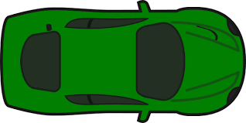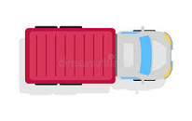

Lost 2300 +

Try again 2300 -

Ok 2000-

Good 1600-

Great Work 1300-

Fantastic 1000-

Excellent -700

Outstanding -500

Alert!!!!!

Break is not working!

Drive it to the repairing shop parking lot to repair it fast!!

You need 3000/- to pay.

You have 500/-

Press ‘space’ to start moving.

fhyru

Alert!!!!!

Error occurred

Break is not working!

Drive it to the repairing shop parking lot to repair it fast!!

You need 3000/- to pay.

You have 500/-

Press ‘space’ to start moving.

fhyru

Lost 2300 +

Try again 2300 -

Ok 2000-

You Win!!! 😊 (outstanding work) 4000/-

Good 1600-

Great Work 1300-

Fantastic 1000-

Excellent -700

Outstanding (you win)-500

You Win!!! 😊 (excellent work) 3500/-

You Win!!! 😊 (fantastic work) 3000/-

You lost!!!! ☹(try again man)

0/-

You lost!!!! ☹  
(good but you can get better…)

1000/-

You lost!!!! ☹(try again man)

750/-

You lost!!!! ☹ (not much good work….) 2000/-